# EPR Battery Attributes

As part of the EPR Battery project, we are going to add the optional attributes *contains_electronics* and *contains_batteries*  to the config tier. These attributes will be linked to all the outlines. Both these attributes are *reference_by_label* with values yes and no.

## Exposure

### Zalando

* Contains Electronics

<ns1:attribute

ns1:attributeKey="contains_electronics"

ns1:description="Contains electronics and electrical components"

ns1:required="false"

ns1:attributeType="OPTION"

ns1:multiSelect="false">

<ns1:valueOption ns1:valueOptionKey="contains_electronics_n">no</ns1:valueOption>

<ns1:valueOption ns1:valueOptionKey="contains_electronics_y">yes</ns1:valueOption>

</ns1:attribute>



* Contains Batteries

<ns1:attribute

ns1:attributeKey="contains_batteries"

ns1:description="Contains batteries"

ns1:required="false"

ns1:attributeType="OPTION"

ns1:multiSelect="false">

<ns1:valueOption ns1:valueOptionKey="contains_batteries_n">no</ns1:valueOption>

<ns1:valueOption ns1:valueOptionKey="contains_batteries_y">yes</ns1:valueOption>

</ns1:attribute>



### Tradebyte

* Contains Electronics

<TAG>

<KEY>contains_electronics@bag</KEY>

<NAME>Contains electronics</NAME>

<VALUES>

<VALUE>

<KEY>contains_electronics_n</KEY>

<NAME>no</NAME>

</VALUE>

<VALUE>

<KEY>contains_electronics_y</KEY>

<NAME>yes</NAME>

</VALUE>

</VALUES>

</TAG>



* Contains Batteries

<TAG>

<KEY>contains_batteries@bag</KEY>

<NAME>Contains batteries</NAME>

<VALUES>

<VALUE>

<KEY>contains_batteries_n</KEY>

<NAME>no</NAME>

</VALUE>

<VALUE>

<KEY>contains_batteries_y</KEY>

<NAME>yes</NAME>

</VALUE>

</VALUES>

</TAG>

### 

### PAI Merchant Attributes - Zalando DI

* Contains Electronics

{

"cardinality": "one",

"definition": {

"type": "LocalizedStringDefinition"

},

"description": {

"de": "",

"en": "Attribute created to identify all products that contain electronic components due several product compliance and EPR related legislation (including Waste Electrical and Electronic Equipment (WEEE) Directive and more). "

},

"label": "contains_electronics",

"name": {

"de": "Enthält Elektronik und elektrische Komponenten",

"en": "Contains electronics and electrical components"

},

"type_variants": [],

"usage": "reference_by_label"

}



* Contains Batteries

{

"cardinality": "one",

"definition": {

"type": "LocalizedStringDefinition"

},

"description": {

"de": "",

"en": "Attribute created to identify all products that contain batteries due to the EPR battery regulation."

},

"label": "contains_batteries",

"name": {

"de": "Enthält Batterien",

"en": "Contains Batteries"

},

"type_variants": [],

"usage": "reference_by_label"

}



## Ingestion

### Zalando (Feed)

* Contains Electronics

<articleConfigAttributes>

<articleConfigAttribute

key="contains_electronics">contains_electronics_n

</articleConfigAttribute>

</articleConfigAttributes>



* Contains Batteries

<articleConfigAttributes>

<articleConfigAttribute

key="contains_batteries">contains_batteries_n

</articleConfigAttribute>

</articleConfigAttributes>



### Tradebyte (Feed)

* Contains Electronics

<A_TAG identifier='key' key='contains_electronics'>

<VALUES>

<VALUE identifier="key" key="contains_electronics_n"/>

</VALUES>

</A_TAG>



* Contains Batteries

<A_TAG identifier='key' key='contains_batteries'>

<VALUES>

<VALUE identifier="key" key="contains_batteries_n"/>

</VALUES>

</A_TAG>



### Submission API - DI

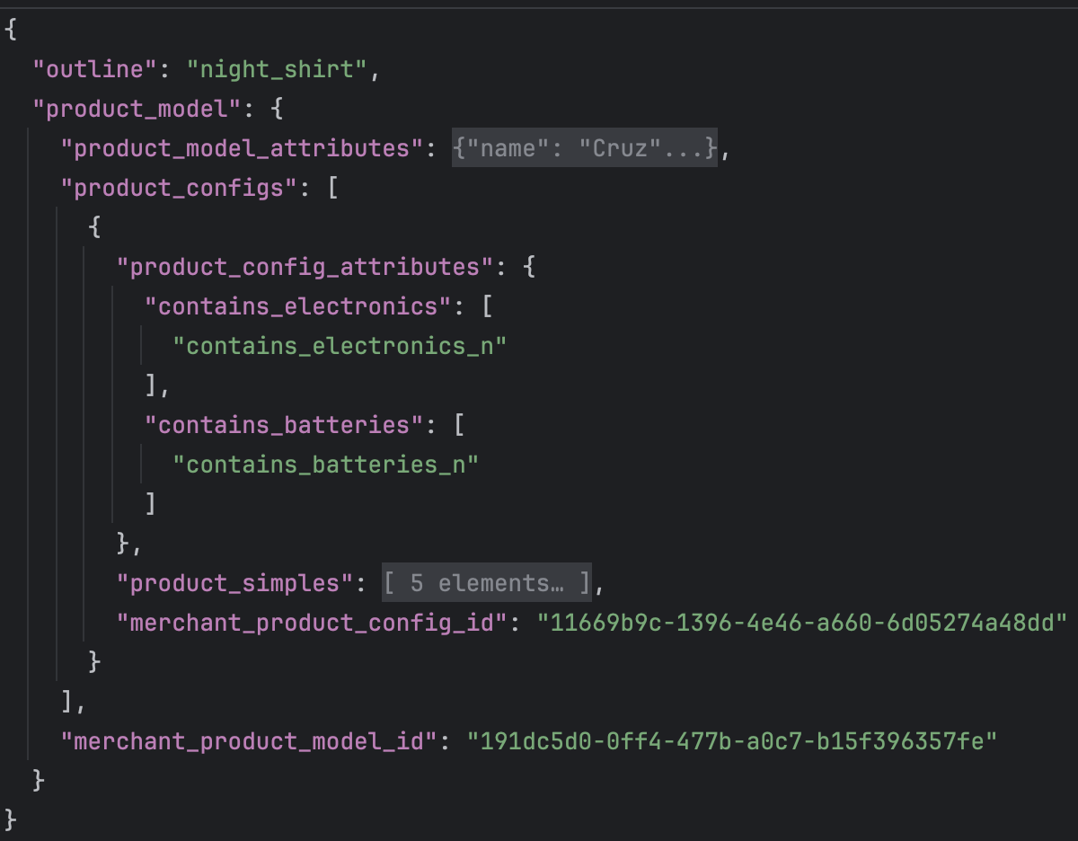

*Note: Other attributes have been omitted for brevity*